Auction Project

The project’s GitHub URL is https://githug.com/william-zwd/Auction.git.

It is a .net core 2.1 project. It is developed by using Visual Studio 2019 community version. Lower version of visual studio should not be able to open it.

The major functionality of an auction web page is data synchronization. One person makes a change on web page, other people currently on the same web page should be able to see the difference. As I demonstrate below, I use two browsers, one is Edge, the other is chrome.

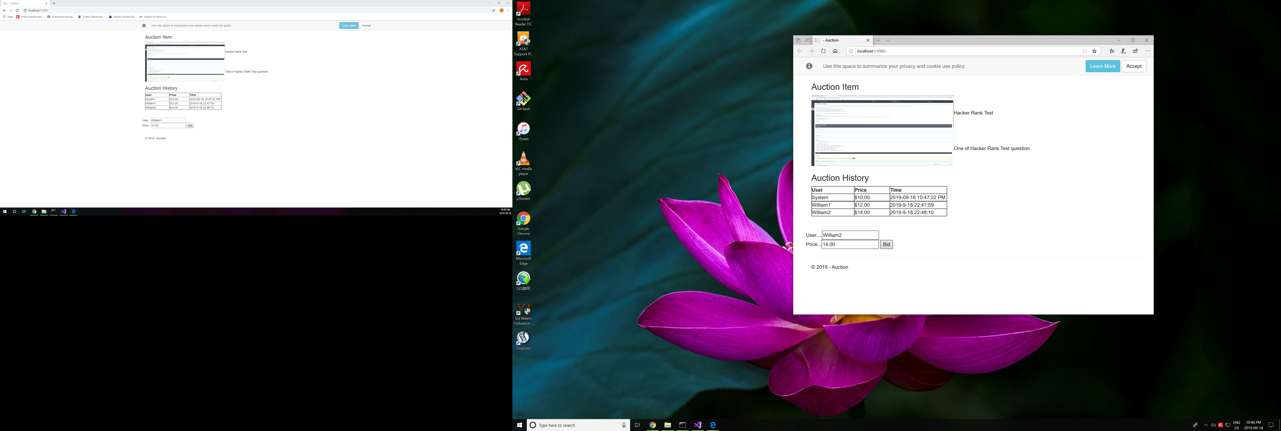

I spent more than 4 hours on this project, mainly spent on setup on the development environment on my personal computer, such as installing Git, Visual Studio 2019, and create repositories in both local and GitHub online.

There are so many improvements can be added to the project. Such as currently it is a simple java script application, there is no MVC. Auction item is hard-coded. There is no check on bidding price, and there is no end of bidding.